**4-1 Journal: Career Choice and Artifact Update**

Christopher King

Southern New Hampshire University

CS-499 Computer Science Capstone 2024

Professor Conlan

November 24, 2024

**4-1 Journal: Career Choice and Artifact Update**

**Part One:**

* **Have you changed your career plans? If so, what prompted this change? If not, why have you remained with your original plan?**
  + My potential career paths have changed multiple times throughout my college career. At first I wanted to focus more on the backend code development, which I am still interested in but when I started working with frontend/UI aspects, I started to enjoy them more. As I progressed to finally take a full-stack class, I think I finally settled on what career I would pursue after college. I like that working with full-stack, I get to do both the backend and frontend which in turn allows me to see the final project progress in real time.
* **How has your thinking about your career evolved?**
  + My thinking about my career has evolved as I learned new skills. Each new skill that I learned, I essentially fell in love with. As I progressed throughout my college career, I have been able to put all those skills to use in different classes and get more comfortable with them. Since I am now at the end of my college career, as I look back I can see what parts I excelled at and which parts I really enjoyed. Having this ability to look back has allowed me to settle on what I wanted to do for my career.
* **Have you completed any research about your choice of career? How has this impacted your thinking? Have you thought about seeking an advanced degree or certification after earning your undergraduate degree?**
  + My plan has always been to continue on to complete my Masters degree in Computer Science, but as I complete my Bachelors degree, I feel it would be better for me to get some real-life experience before I continue on for my Masters. I have not done any research on individual certifications that I could complete, but I do plan on completing that research.
* **Which course outcomes have you achieved so far, and which ones remain?**
  + At this point in my project, I believe that I have shown evidence in all areas of improvement. That being said, I plan on improving my project to enhance the look of the front end, restricting the registration to either have to be approved or making it so only certain people have the ability to register, and working to improve the available filters in the animal list.

**Part Two:**

* **Software Design and Engineering**
  + **Progress:** My updated app shows clear evidence of design improvements. The transition from java to a structured full-stack application demonstrates improvement on modern development paradigms.
  + **Next Steps:** Ensure design documentation aligns with enhancements to showcase the engineering process in the ePortfolio.
* **Algorithms and Data Structures**
  + **Progress:** The enhanced app implements encapsulation and the Factory Method, showcasing improvements in organizing and improving code efficiency.
  + **Next Steps:** Further optimize algorithms to handle large data or new animals for rescue operations.
* **Databases**
  + **Progress:** The use of MongoDB indicates the understanding of NoSQL databases. Current database interactions support storing and retrieving animal data efficiently.
  + **Next Steps:** Expand database schema to include additional data and ensure seamless front-end integration.



**Screenshots on Enhancements made this Module:**

**Original Home Screen**

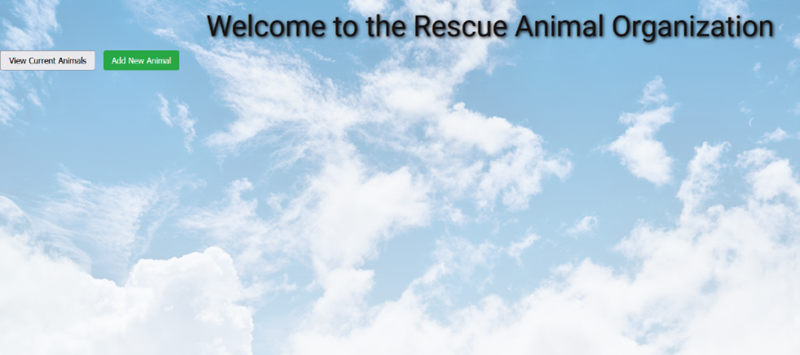

**Enhanced Home Screen (Not Logged In)**

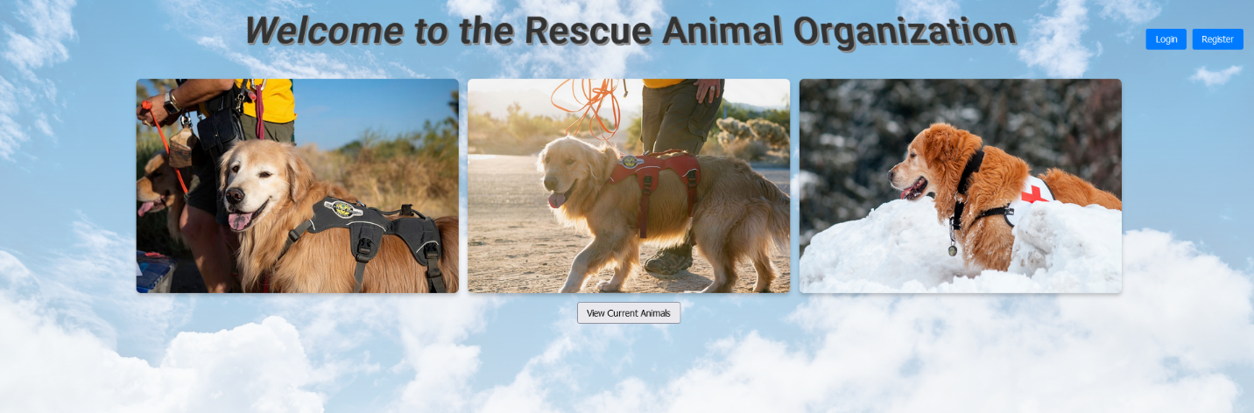

**Enhanced Home Screen (Logged In)**

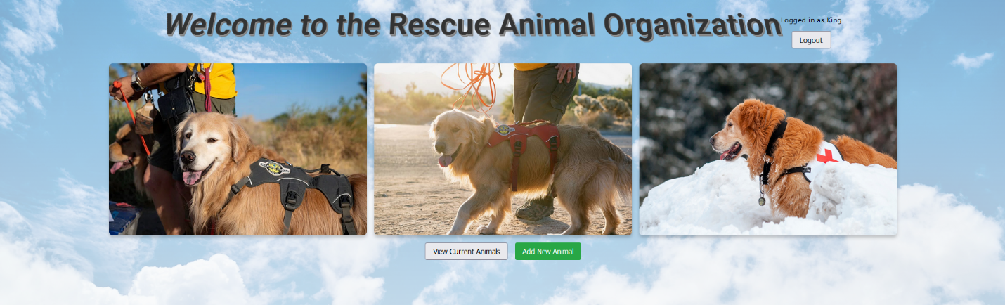

**Original Animal List**

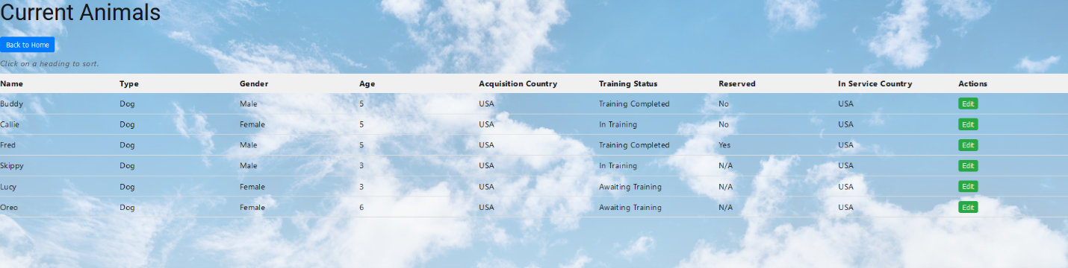

**Enhanced Animal List (Not Logged In)**

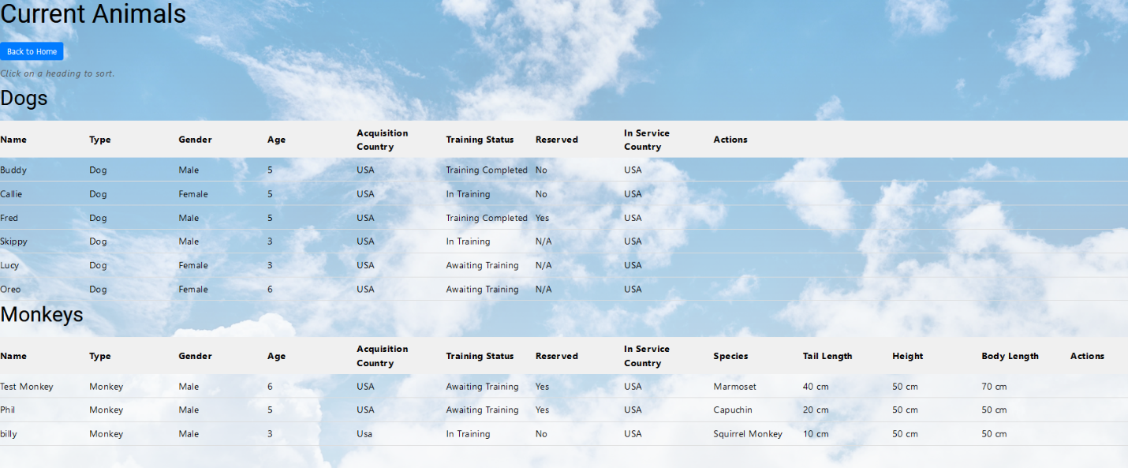

**Enhanced Animal List (Logged In)**

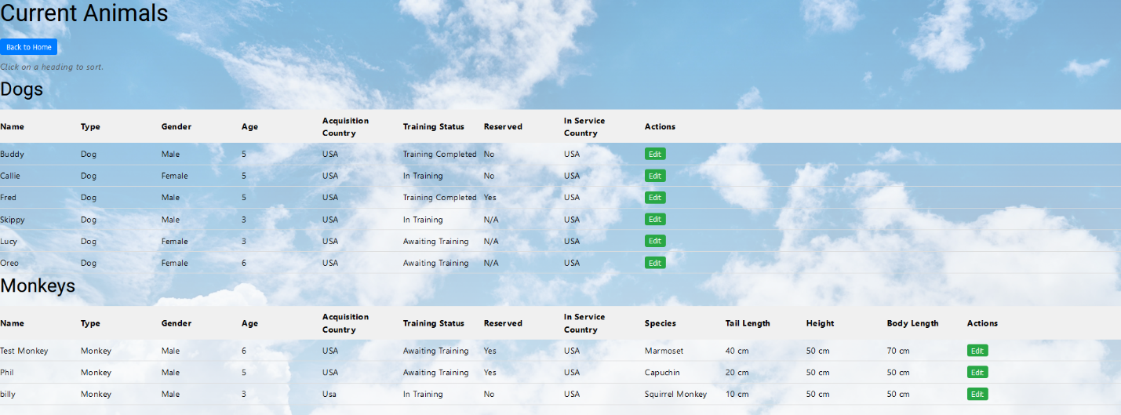

**Original Intake Form**

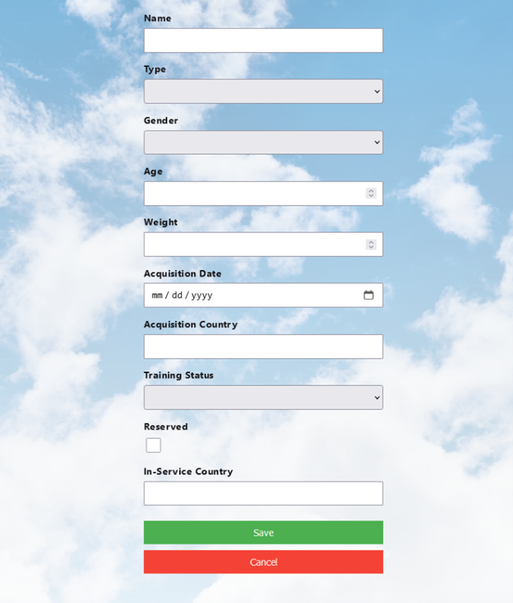

**Enhanced Intake Form**

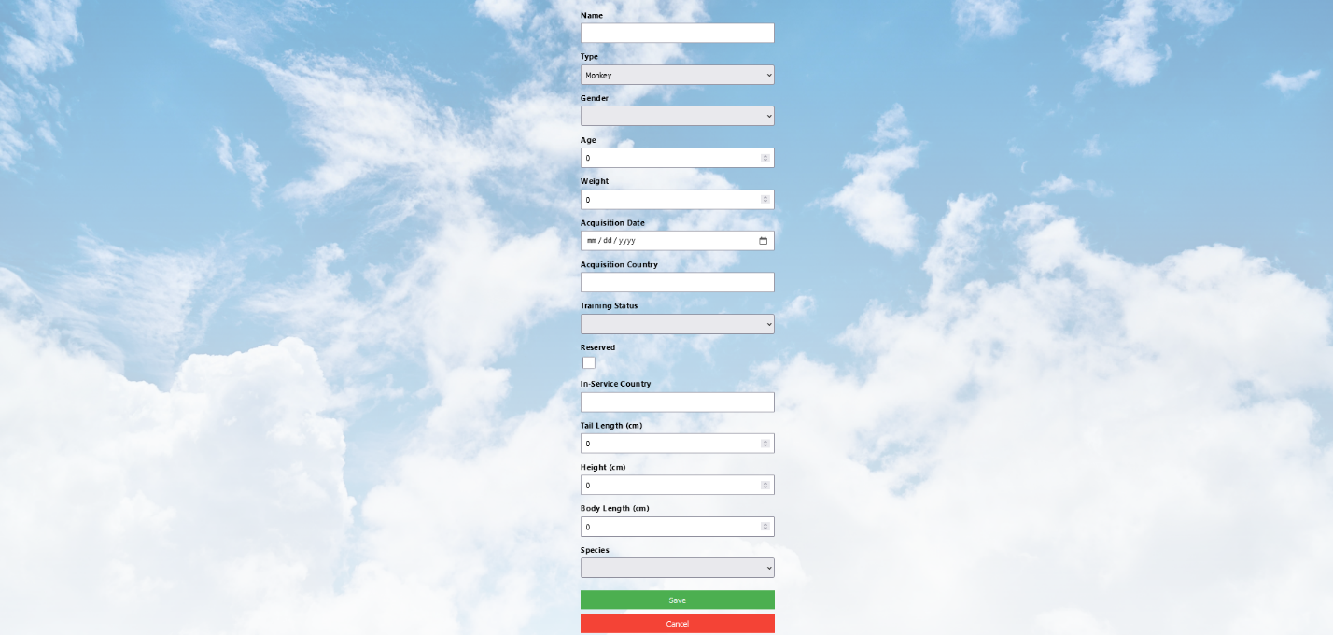

**New Login Screen**



**New Register Form**

